What all to know from Experimental Design and Sequencing Choices to start with Bulk RNA-seq Analysis

Good bioinformatics cannot rescue poor design, but good design enables robust, interpretable analysis.

1. Experimental Design: the foundation of valid analysis

Biological replicates
Biological replicates capture natural biological variability and are essential for estimating variance. In bulk RNA-seq, a minimum of three biological replicates per condition is required to perform statistically valid differential expression (DE) analysis.
Fewer replicates dispersion cannot be estimated reliably, leading to unstable or meaningless p-values.

Bioinformatics impact
- Determines statistical power
- Enables valid DE modeling (e.g. DESeq2, edgeR)
- Insufficient replicates → exploratory results only

Case–control vs time-series designs
A case–control design compares discrete conditions (e.g. disease vs control), while a time-series design models expression changes across multiple time points. These designs require different statistical models and assumptions.

Bioinformatics impact
- Case–control: ~ condition
- Time-series: ~ time or ~ subject + time
- Wrong model choice → incorrect conclusions

Batch design and randomization
A batch is a group of samples processed under the same technical conditions. Batch effects are unavoidable, but confounding is avoidable.

Bioinformatics impact
- Balanced batches → modelable (~ batch + condition)
- Batch = condition → no valid DE possible
- Batch effects dominate PCA if not handled correctly
Bad PCA where the clusters are by the bathes notconditions

2. RNA selection strategy: what transcriptome needs to be seen

Poly(A) selection
Enriches polyadenylated mRNA, producing a clean, protein-coding-focused dataset. Requires good RNA quality.

rRNA depletion
Removes ribosomal RNA while retaining coding and non-coding RNAs.

3. Library properties: structure matters

Strandedness
Strandedness indicates whether reads retain information about the DNA strand of origin. Strandedness has no relation with paired or unpaired reads.

Bioinformatics impact
- Correct strandedness → accurate gene counts
- Wrong strandedness → silent misassignment and false DE

Paired-end vs single-end sequencing
Paired-end sequencing reads both ends of a fragment, improving mapping accuracy and splice detection.

4. Sequencing depth and platform choice

Sequencing depth - the number of reads per sample.
The more >> better is the detection of genes/transcripts

Bioinformatics impact
- Low depth → noisy PCA, false negatives
- Uneven depth → biased variance estimation

5. Controls and spike-ins
Spike-ins are synthetic RNAs of known concentration added before library prep – to know about technical variability(no effect on biology)

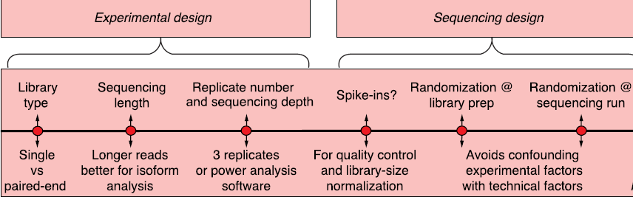

What bioinformaticians must always know before analysis
- Number of biological replicates
- Batch structure and randomization
- RNA selection method
- Strandedness and read layout
- Sequencing depth and platform
- Whether spike-ins were used

References
1. Conesa et al., A survey of best practices for RNA-seq data analysis, Genome Biology, 2016. [old but very fundamental]
2. Schurch et al., How many biological replicates are needed in an RNA-seq experiment?, RNA, 2016.
3. Love et al., Moderated estimation of fold change and dispersion for RNA-seq data with DESeq2, Genome Biology, 2014.
4. Risso et al., Normalization of RNA-seq data using factor analysis of control genes or samples, Nature Biotechnology, 2014.
5. Illumina Technical Notes: Effects of index hopping and multiplexing on sequencing data.

